The Rhododendron
A Publication of:
MOUNTAIN STATE COUNCIL OF THE BLIND, INC
131 Heritage Pt.
Morgantown, WV 26505
(773) 572-6304
www.mscbwv.org
SEPTEMBER 2021
Editors: Public Relations Committee

President’s Message
Dear MSCB Members,
As we make the transition from summer to fall, plan to take part in the MSCB convention during the first weekend in November. Along with attending the convention, think about what part you can play in making MSCB a stronger organization. There is a place in the day-to-day activities of MSCB for everyone.
A big thank-you to Chris Cook for running a fabulous 7-up call this month. Ideas for future 7-up calls are always welcome. If you have a skill you want to teach, a gadget you want to talk about, or just a discussion topic you want to facilitate, the door is always open.
All MSCB board meetings are open for members to attend. Our board meetings usually take place at 8:00 PM on the second Tuesday of the odd-numbered months. Please join us and participate in the discussion.
Until next month, stay well and enjoy the fall foliage.
Sincerely,
Donna Brown, President

MSCB Moments
MSCB State Convention Update:
Tentative Convention Schedule
Friday, November 5
3:00—5:00 PM: MSCB business meeting
7:00—9:00 PM: Exhibitor presentations
9:00 - 10:00 PM: Entertainment
Saturday, November 6
9:00—12:00: Presentations by various speakers
1:00—4:30: Speaker presentations
6:00: Banquet
7:30: Virtual auction
To help make our convention more fun and successful, please donate items for our auction and/or door prizes. Please notify us by emailing the MSCB members list with a description of your gifts.

Tech Talk

Aira Plans for ACB Members
Aira is a service that connects blind and low vision people to highly trained, remotely located agents. Through an app on your smartphone, Aira delivers instant access to visual information at the touch of a button – enhancing everyday efficiency, engagement, and independence. Aira offers two special pricing plans for ACB members. The Intro Power Plan includes 30 minutes per month for $20.00, and the Standard Power Plan includes 140 minutes per month for $99.00. These plans are available for ACB members in good standing who sign up through December 31, 2021. Please contact Customer Care at (800) 835-1934 for more information and to confirm your status to purchase a plan.

Obituary of Mitzi Friedlander
Mitzi Friedlander, 91, passed away on 8/11/21. Mitzi was a performer (actress and singer), narrator of Talking Books, social activist, teacher, mentor, and friend to many across Louisville. Her light brightened many rooms and lives. She loved big parties with friends, especially the legendary Friedlander Christmas parties.
Her true vocational passion was her work for the American Printing House for the Blind. It is not an overstatement to say that Mitzi was a superstar for people who are blind or visually impaired. She narrated Talking Books for over 50 years and recorded more books than anyone over the course of her career. She often gave talks to local chapters of the American Federation for the Blind. Anyone I ever met who was blind or visually impaired always knew Mitzi. It only took someone to hear the name, Friedlander, and they would ask, “are you related to Mitzi’? While she loved her readers, and their kind notes, she absolutely adored their dogs. Often, they would hear her voice and recognize her from the hours their partners had listened to her narration. I made a photobook for her made up entirely of these guide dogs. She loved it .Her voice will be missed by many Bard listeners! Our special condolences to the Kentucky chapter of ACB!

Poem September by Helen Hunt Jackson
SEPTEMBER
The golden-rod is yellow,
The corn is turning brown;
The trees in apple orchards
With fruit are bending down.
The gentian’s bluest fringes
Are curling in the sun;
In dusty pods the milkweed
Its hidden silk has spun.
The sedges flaunt their harvest,
In very meadow nook;
And asters by the brook-side
Make asters in the brook.
From dewy lanes at morning
The grapes sweet odors rise;
At noon the roads all flutter
With yellow butterflies.
By all these lovely tokens
September days are here,
With summer’s best of weather,
And autumn’s best of cheer.
But none of all this beauty
Which floods the earth and air
Is unto me the secret
Which makes September fair.
‘Tis a thing which I remember;
To name it thrills me yet:
One day of one September
I never can forget
Helen Hunt Jackson

Cook’s Corner
Blackberry Cobbler

1 cup sugar
1 cup flour
1-1/2 tsp baking powder
¼ tsp. salt
1 cup milk
1 stick butter melted
2 cups fresh or frozen blackberries, if using frozen berries partially thaw them in frig before using.
Zest of ½ lemon
1 tbsp. lemon juice
Extra sugar for topping

Preheat oven to 350 degrees. In a large bowl, whisk together flour, baking powder, salt and sugar. Stir in the milk, lemon zest, and lemon juice. Next stir in the melted butter, and mix till well combined. Pour in to a greased 9 x 9 inch baking dish. Distribute the berries over the top, and sprinkle ¼ cup sugar over top. Bake for 50 minutes, sprinkle 2 more tbsp sugar on top. Return to oven for 10 more minutes, till golden brown. Serve warm with vanilla ice cream.

Let’s Go Shopping virtual event
Small biz entrepreneurs, are you looking for another way to showcase your products? Join us for the next Let's Go Shopping virtual event!
My name is Laura, and I'm the founder of an online, accessible, virtual mall crawl called Let's Go Shopping. With the uncertainty of the most recent surge of Coronavirus cases, shipping slowdowns, and supply chain interruptions, the 2021 holiday season may prove to be a challenging one. I'm connecting small businesses with the customers who need them!
The next Let's Go Shopping extravaganza is planned for early November, and I'm seeking new vendors to participate. Are you a small business owner? Are you a sole proprietor, an Etsy shop owner, or an artist selling your work? If you sell fashion, accessories, food, gadgets, beauty products, handcrafts, or gift items, Let's Go Shopping may be for you. Think of Let's Go Shopping as a way for you to introduce yourself and your products to a whole new audience. You'll meet other business owners, chat with shoppers, gain exposure, and make more sales!
How to join us: There's lots to know with respect to how the event runs, and there is a vendor guidelines page that will answer most of your questions. Below is a brief summary.
* Whether you want to participate as a vendor or a shopper, the first step is to subscribe to our email group list. This is our announce-only email list through which all relevant LGS announcements are made. Select the link below to go to the Let's Go Shopping main info page, and opt-in by entering your email address. https://accessibleinsights.info/blog/lets-go-shopping/
To verify you are a human, there is an accessible CAPTCHA, but if you don't want to deal with it, you can also send a blank email to: lgs+subscribe@groups.io and you will be added to the list.
* After you subscribe, scroll down the page to read a brief summary of the participation guidelines, then click the contact link to introduce yourself and let me know of your interest. I will then send you a link to the full vendor guidelines and terms of service. It's all very common-sense stuff, but the guidelines pages detail the expectations and responsibilities as to vendor conduct, customer service, and the general standards for participation. There is also a registration fee for all participating vendors.
Who can present products during Let's Go Shopping?
If you are the owner of a small business, with fewer than a handful of employees, sell tech gadgets, fashion, handcrafted goods, art, accessories, candy or treats, have an ecommerce business or Etsy store, and are fully responsible for shipping, inventory, and logistics, you are a great fit.
Vendors are not required to have a disability, but it is imperative that accessible shopping options are available. Whether that's an accessible website, or email or phone ordering availability, it doesn't matter, so long as every effort is made to accommodate shoppers with disabilities.
What types of businesses are not eligible?
Sorry, but product representatives, such as Avon associates, Melaluca, Tupperware reps, etc. are not eligible. Amway or other multi-level marketing networks are not allowed. You must be an established, independently owned and operated, autonomous business. If you offer a service, we may consider you on a case-by-case basis. Remember, this is a retail holiday shopping event, so unless your services are packaged and promoted in a way that is giftable, this event may not be for you.
There's more, but if you are already intrigued, I encourage you to go to the main Let's Go Shopping info page linked below...
https://accessibleinsights.info/blog/lets-go-shopping/
...and get in touch. It will be my pleasure to answer all your questions. I can also put you in touch with past participants, if you would like to get some feedback on the Let's Go Shopping experience.

Gold Medalist Brad Snyder tells his story

'It keeps me awake at night': Paralympic gold medalist blinded in Afghanistan questions US' 'war on terror'
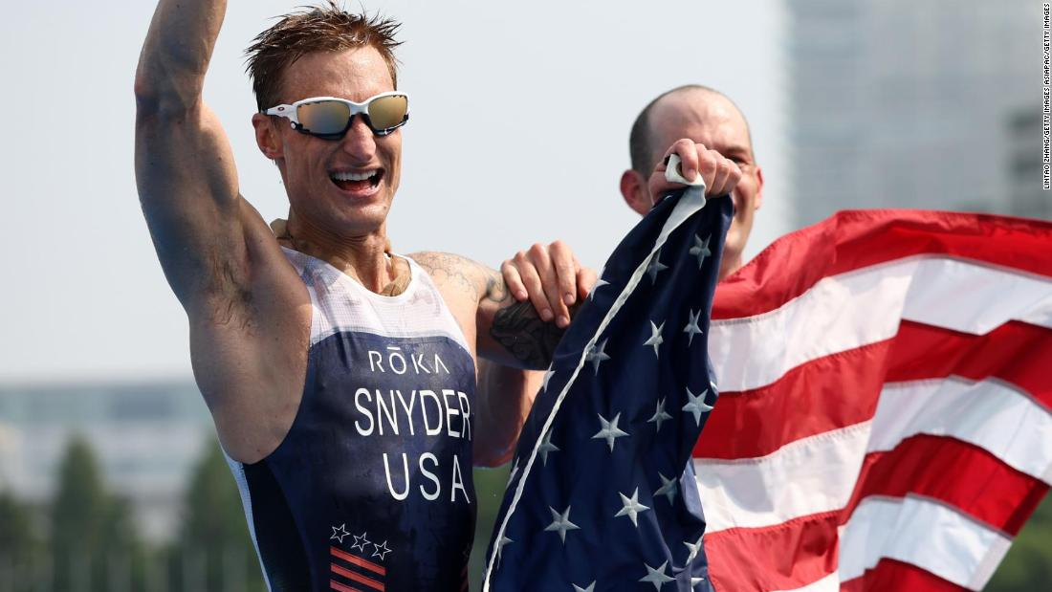
Tokyo(CNN) — A history-making US Paralympic gold medalist, who was blinded while serving with the American military in Afghanistan, says he questions whether or not the 20-year long "war on terror" was worth it.
Brad Snyder became the first American man to win an individual triathlon event in either the Olympics or the Paralympics when he clinched paratriathlon gold in the PTVI category in Tokyo on Saturday, crossing the line with guide Greg Billington in a time of 1:01:16.
The 37-year-old had only made the switch to the event three years ago, having already claimed a glittering haul of medals in Paralympic swimming.
"This has been a long journey, my transition into triathlon over the past few years, there's been a lot of major obstacles ... I'm really thankful to be here, really thankful the Paralympics happened," he told CNN's Selina Wang after winning his sixth Paralympic gold Saturday.
Snyder was a member of the US Navy's elite bomb disposal squad for seven years, serving in Iraq and Afghanistan -- where he was permanently blinded after he stepped on an improvised explosive device (IED) during a tour of duty in 2011.
He said in the immediate aftermath of the explosion he was surprised to still be alive. "Thankfully, I was alone when I got hurt, so it only affected me and, thankfully, it detonated a short distance in front of me ... which largely saved my life and saved my limbs," he said.
US Paralympic gold medalist Brad Snyder speaks with CNN.
Snyder's victory comes amid turmoil in Afghanistan as US troops withdraw from the country, which is now back under the control of the Taliban.
He said he felt "prevailing sadness" over the hardline Islamist group's return to power, but added he understood the US military couldn't stay in Afghanistan "forever."
"The mistakes of the last 20 years don't justify future investment in my view," he said. "We've quelled the violence for 20 years and stability has not prevailed ... removing yourself is incredibly challenging."
Synder said he was unsure whether the US' "war on terror" in Afghanistan and Iraq over the past 20 years had been worth the cost. "It plagues me, it keeps me awake at night and I think about it a lot, especially being a person whose life was fundamentally changed by going to Afghanistan," he said.
Snyder said he is studying for a PhD in Public Policy at Princeton University to try and "make sense" of the questions about whether the war in Afghanistan was worth it. His intention is to return to the US Naval Academy to help mold a future generation of American military leaders and prepare them for the "fights of tomorrow."
He said the thought of teaching future officers helped him to "make sense" over questions about whether the war in Afghanistan was worth it.
But Snyder said he didn't view his sacrifice as for the people of Afghanistan, but for the "notion of liberty, the notion of freedom" and "human rights."
"And that sacrifice, that fight is still alive, that fight is something we'll be fighting until long after I'm gone," he said.
Snyder and guide Greg Billington celebrate their triathlon gold on the podium in Tokyo on August 28.

Blind Bloopers
All are invited to enter any recent or ongoing Blind Blooper.
Here are Mucie’s two most recent:
Why can’t I remember to place my shoes in the proper position for reinserting my feet?
Why does my electric toothbrush fall off the shelf?
The answer is that not carefully placing an object means you are headed for a blooper so let’s shape up and make our lives easier. I swear this time I will take my own advice and change my attitude with the change of seasons. HAPPY AUTUMN!

A case of mistaken identity by Marcia Springston
Recently a guy was painting our back porch; I was busy in my pottery shop and forgot about him. At noon, when I walked over to the house, I heard someone walking on the driveway, so I called out “honey, are you ready for lunch?” I got no reply, but there was a mower making a lot of noise. I repeated my question even louder, again with no answer. When I went into the house my husband was in the kitchen, and said “are you ready for lunch?” Oops, so who was the person in the driveway?

ALL ARE INVITED TO RECOMMEND BOOKS
from Mucie Allred

REACH FOR MORE by David M Szumowski
BARD #99056 read by Steven Van Doren
Inspiring story of a blinded U S soldier. The story is told by him in this autobiography of dealing with the trauma of sudden vision loss and how he became a judge when he was told that he could not get through law school.

THE BLIND TRUTH by Woody Livingston
BARD #99277 read by John Huffman
This is a story in the author's own words about losing hearing along with vision due to Usher's Syndrome.

PEOPLE OF VISION
by James Medivern and Marjorie Medivern
BARD #56114 read by Mark Ashby
Written in 2003, this tells the story of the creation of ACB . It is being discussed on a community call with people who lived it.

FORWARD TOGETHER
By Christie Bane DB #00008
Read by Christin Allison
An inside look at guide dog training.

MONSIEUR PAMPLEMOUSSE
by Michael Bond
This is a series of cozy mysteries with an ex French policeman and his faithful bloodhound who is also an ex-police officer. The author is Michael Bond who wrote PADDINGTON BEAR and these characters are just as endearing. Look for Monsieur Pamplemousse in the title.

Like in the Sixties Quiz answers
Remember the quiz you took in the August issue of this newsletter? The letter x will appear before the correct answer to each question.
1. What was the price of a gallon of milk in 1960?
$0.50
$1.20
$2.05
X $0.36
2. What was the median cost of a single-family home in the 1960s?
$5,100
X $11,900
$22,600
$28,000
3. How many people were age 65 and older in 1960?
40.8 million
25.4 million
64 million
X 16.2 million
4. How many older adults were living in their own homes in the 1960s?
X 4.7 million
10 million
13 million
2 million
How did you do?

Important Announcement:
Hello ACB Members,
The strength of ACB is our membership and their commitment to the mission of the organization. We will be finalizing the ACB Committee member rosters for this year, and we would welcome new leaders to join our committees. Please drop me a note at
dspoone@acb.org or give me a call at (407) 227-4489 if you would like to learn more about an ACB Committee or would like to express your interest in volunteering for an assignment. The list of ACB Committees can be viewed at https://acb.org/committees.
You are not alone in your journey through vision loss and blindness. The American Council of the Blind (ACB) welcomes and accepts you. Guided by its members, ACB advocates for equality of people who are blind and visually impaired, inspires community, and connects you with education, resources, and each other to support your independence.
Let’s all work together to fulfill our mission. I look forward to hearing from you.
Dan Spoone
ACB President

Calendar of Events
September 28: ACB board meeting, 8:00 PM.
October 8-9: Fall board meeting.
October 11: It’s 7-up Time!
October 15: White Cane Day and ACB Get up and Get Moving Campaign dance party.
November 5-7: MSCB state convention.
November 9: It’s 7-up Time.
November 10: 8:00 PM MSCB board meeting, open to all members.

